NAME: DATE:

BOXED-IN: BY THE NUMBERS
Below is a timeline and a graph. Use the information provided in the timeline and graph to answer the questions below.

US Women Timeline

1939-1945- World War II
1941- The United States enters WWII.
1960- US Food and Drug Administration approves the birth control pill.
1964- Congress passes the 1964 Civil Rights Act which prohibits discrimination in employment on the basis of race, color, national origin, religion, and sex.
Early 1960s-late 1980s - 2nd wave of feminism. Mid 1990s-2010- 3rd wave of feminism.

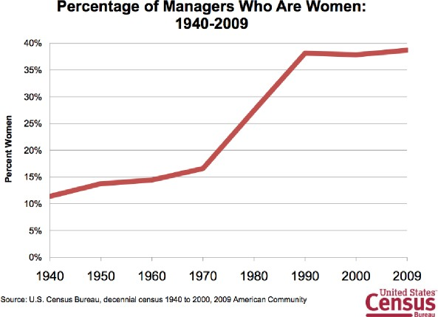

- What major event of the 1940s resulted in more women joining the workforce? How do think this event changed the perception of what women could do around that time? Explain.

- During which period of time did the percentage of female managers increase the most sharply? What historical movement could explain this change?

- During which time period did the percentage of female managers appear to level out? Why do you think this happened?

